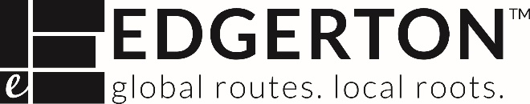

**REQUEST FOR DESIGN TEAM QUALIFICATIONS**

**FOR SITE #2 and SITE #3 DWYER SANITARY SEWER IMPROVEMENTS**

The City of Edgerton is seeking qualifications from Design Teams for the engineering and design of Site #2 and Site #3 of the Dwyer Sanitary Sewer Improvements Project. This project would design the improvements and equipment upgrades at Site #2 and Site #3. Site #2 improvements to the existing City Pump Station including a new equalization basin and associated piping and upsize the existing 8-inch, approximately 245 linear feet of sanitary sewer. Site #3 includes upgrading and improving the SCADA system and replacement of aged equipment at the BBCWWTP. The project team will analyze the existing plant and pump station for functional improvements, redundancy, and modernization as needed. The project team will also understand the existing sanitary sewer system and treatment process to identify possible cost savings with existing infrastructure being sized to accommodate the anticipated increased flow associated with the Dwyer Farms development. The project team would assist the City in evaluating and determining the appropriate improvements to these two project sites. The project team would assess the additional needs for construction (additional equipment and systems), and work with appropriate permitting agency in preparation for bidding the construction phase of the needed improvements.

This project is partially funded through the Environmental Protection Agency’s (EPA) Community Grant Program and the Kansas Department of Health and Environment’s (KDHE) State Revolving Fund (SRF) loan program. State and Federal contract provisions will be included in the contract between the City and the Design Team.

The Request for Qualifications may be examined in the City Clerk’s Office of Edgerton City Hall at 404 East Nelson, Edgerton, Kansas 66021. The Request for Qualifications is also available at the city’s website at [https://edgertonks.org/departments/public-works/bids-and-requests-for-proposal/.](https://edgertonks.org/departments/public-works/bids-and-requests-for-proposal/) Responses must be submitted to the City of Edgerton prior to **4:00 PM on Thursday, August 15**. Completed Statements of Qualifications shall be sealed and clearly marked “SITE #2 and SITE #3 DWYER SANITARY SEWER IMPROVEMENTS.” Any questions shall be directed to Holly Robertson at hrobertson@edgertonks.org.